**Excel Project (Adidas Sales)**

# Project Overview

This project uses the ***Adidas Sales Dataset*** to perform a comprehensive sales performance analysis for Adidas products across different regions and retailers. The main goal is to uncover sales patterns, identify high-performing products and locations, and create an interactive Excel dashboard for business decision-making

# Dataset Description

The dataset contains detailed transactional data including:

* **Retailer Information:** Retailer, Retailer ID, Region, and State
* **Product Information:** Product, Product Category, and Units Sold
* **Sales Metrics:** Total Sales, Operating Profit, Price per Unit, Gross Sales
* **Temporal Data:** Year, Month, and Date of Order

# Business Objectives

The primary objectives of this project are:

* Analyse **Adidas sales** performance across regions and retailers.
* Identify top-performing products and their contribution to revenue.
* Measure profitability by product and region.
* Understand sales seasonality and time-based trends.
* Develop a dynamic dashboard for quick management insights

# Key Business Questions

**Sales & Profit Performance**

* **Which region generates the highest sales and profit?**
* **How do sales trends change monthly or yearly?**
* **Which retailers contribute most to Adidas revenue?**

**Product Analysis**

* **Which products or product categories drive the highest sales?**
* **Which items deliver the best profit margins?**
* **Are there any underperforming products that impact total profit?**

**Retail & Market Insights**

* **Which retailer performs best across all regions?**
* **How do regional preferences affect product sales?**
* **What is the average price per unit by region or product category?**

**Operational Insights**

* **How does the number of units sold correlate with profit?**
* **Which regions or retailers maintain the best profit-to-sales ratio?**

# Tools & Techniques

**Microsoft Excel**

* Data Cleaning using Power Query
* Pivot Tables & Pivot Charts
* Formulas: SUMIFS, AVERAGEIFS, IFERROR, VLOOKUP, INDEX-MATCH
* Conditional Formatting for KPI highlighting
* Interactive Dashboards using *Slicers & Timelines*
* KPI Cards and Custom Visualizations

**Deliverables :**

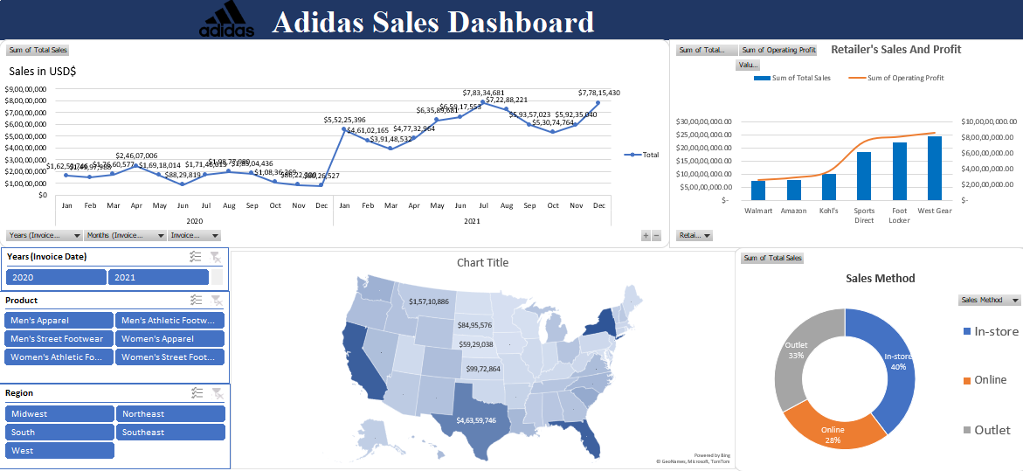

**Insights :**

* Foot Locker and Sports Direct are the top-performing retailers, driving maximum revenue and profit.
* Men’s Apparel and Men’s Athletic Footwear are the most profitable product categories.
* Sales peaks during mid-year months (June–September), indicating strong seasonal and promotional demand.
* In-store and Outlet channels contribute over 70% of total sales, showing dominance of offline retail.
* South region records the highest sales (≈ $46 M), followed by the West and Midwest regions**.**

**Future Enhancements:**

* **Integrate year-over-year comparison visuals.**
* **Include forecast analysis using Excel trendlines or Power BI.**
* **Automate report refresh using Power Query connections.**
* **Expand to global Adidas data for broader insights.**